14.021 |  | Carousel Frequency
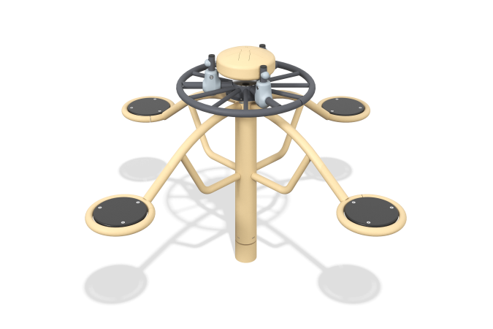

Size, mm: | 1847x1847x1046 | Weight, kg: | 76.97
Material characteristics
General description of the design
The carousel is a connection of a supporting fixed part, a vertical round pipe (with one degree of freedom), as well as round arc-shaped pipes with frame reinforcement elements, which are the basis for the seats. In the upper part of the carousel (on the stationary “steering wheel”) there is an anti-vandal drum “glucophone”, which creates sound vibrations of different frequencies when hitting its surface in different areas.
Materials and components
Powder-painted steel with a layer of zinc-containing primer, HPL plastic and (or) HPL panels, stainless fasteners. The frame is made of a support - a pipe with a diameter of 108 mm and a wall thickness of 3 mm and seats made of pipes of a smaller diameter. A static “steering wheel” with a fixed musical element is attached to the base.
The carousel shaft is made of steel grade no lower than 20. Rotation is ensured by two bearing units. The embedded flange with gussets is covered with a plastic casing.

