11.013 |  | Seesaw Singapore
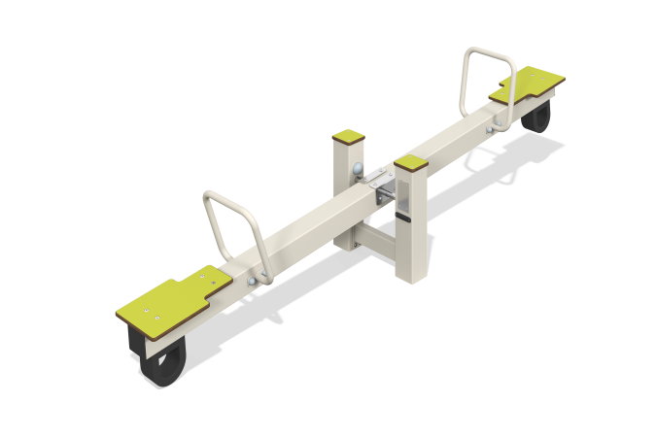

Size, mm: | 482x2602x638 | Weight, kg: | 52.22
Material characteristics
Materials: Structural steel – Frame structures: profile 100mm x 100mm, wall thickness 4 mm, diameter 60mm, wall thickness 8 mm; sheet 2mm thick,
sheet 6mm thick; Circle diameter 26mm, diameter 36mm, diameter 40mm; The fittings are 16mm, the plugs are polyethylene, the seats are HPL plastic, the bumper is rubber.
Coating of elements: Polymer coating of metal. Galvanized fasteners.
The balancer has one axis of rotation - around a horizontal axis. Rolling is carried out using a bearing. The maximum number of simultaneous users is two.
Contents: Stand – 1 pc., beam assembly – 1 pc., seats – 2 pcs., fastening kit – 1 pc.

