13.072 |  | Play System Beryllium
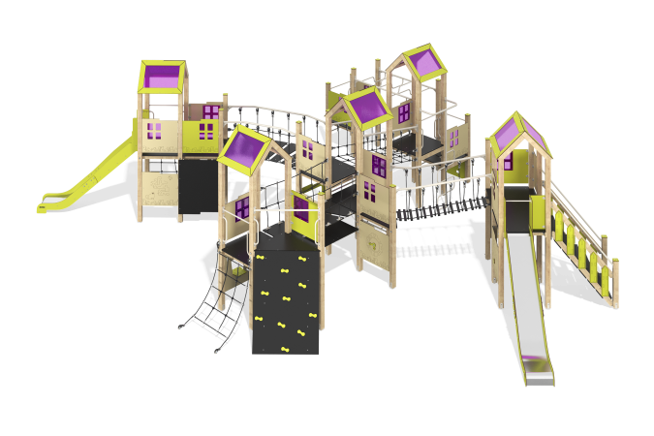

Size, mm: | 8626x12106x3470 | Weight, kg: | 1434.873
Material characteristics
Main materials: softwood timber, planed softwood board, laminated plywood with anti-slip coating, HPL plastic, metal, stainless steel, monolithic polycarbonate, reinforced polypropylene rope, stainless fasteners.
Contents: embedded parts – 1 set, support posts – 36 pcs., roofs – 5 sets, floors – 1 set, straight slide h=1.5m – 2 pcs., metal handrails – 11 pcs., vertical wooden fences – 4 pcs., fencing and decorative panels – 1 set, staircase – 1 pc., staircase with decorative panels – 1 pc., climber panel with hooks – 1 pc., balcony – 1 pc., inclined rope mesh – 1 pc., rope bridge – 1 pc., climber panel with grooves for legs – 1 pc., vertical pole – 2 pcs., handrails – 1 set, fastening set – 1 pc.
Design and color palette of equipment according to the sketch.
The gaming complex consists of 5 towers. The support posts are made of laminated softwood timber with a cross-section of 100x100 mm. The profile is square, the corner radius is R10.
The transitions between the towers are presented in the form of a rope bridge with steps, a rope bridge without steps and an inclined rope ladder with steps made of six-strand reinforced polypropylene rope d=16 mm, the bridge steps are made of laminated plywood 18 mm thick with an anti-slip coating, the inclined ladder steps are made of laminated plywood 18 mm thick with anti-slip coating and HPL plastic linings. The rope bridge railing is made of a metal pipe with a diameter of 42.3 mm and a wall thickness of 2.8 mm.
The floor frames are planed softwood boards with a section of 100x30 mm, 100x40 mm. The floors and steps are made of laminated plywood 18 mm thick with an anti-slip coating.
The roofs of the towers are gable, made of a combination of frames made of HPL plastic with monolithic polycarbonate, onto which color coating is applied using UV printing.
Fencing and decorative panels, game elements are made of double-sided HPL plastic with UV protection, 10 mm thick. Drawings are applied to panels and game elements using engraving and UV printing. Decorative inserts on the panels in the form of windows are made of monolithic polycarbonate 5 mm thick with color coating. Transparent panels are made of monolithic polycarbonate 10 mm thick.
- climber panels with grooves for legs, made of HPL plastic 10 mm thick;
- climber panels with hooks, made of laminated plywood 18 mm thick with an anti-slip coating;
- inclined rope mesh made of six-strand reinforced polypropylene rope d=16 mm.
The handles are made of metal pipe with a diameter of 26.8 mm and a wall thickness of 2.8 mm.
Metal crossbars are made of a round pipe with a diameter of 21.3 mm and a wall thickness of 2.8 mm.
The bridge handrails are made of pipe with a diameter of 33.5 mm and a wall thickness of 2.8 mm
The vertical pole is made of a pipe with a diameter of 42 mm with a wall thickness of 2.8 mm
The staircase with decorative panels is made of 24 mm thick plywood, the steps are made of 18 mm thick laminated plywood with an anti-slip coating. The railings are made of pipes with a diameter of 33.5 mm and a wall thickness of 2.8 mm. Decorative panels are made of double-sided HPL plastic with UV protection, 10 mm thick.
The play complex includes two straight slides. The slides h=1.5 m consist of a slope and sides, in turn made of stainless steel sheet 1.5 mm thick and HPL plastic 10 mm thick. The launch pads for straight slides are equipped with a metal crossbar made of a round pipe with a diameter of 21.3 mm and a wall thickness of 2.8 mm. The complex uses stainless steel fasteners. Protruding parts of threaded connections and open parts of pipes are closed with plastic plugs.
Element coverage:
- metal - powder zinc primer, powder paint;
- timber - glazing primer, water-dispersion varnish.

