35.012 |  | Dog walk ramp
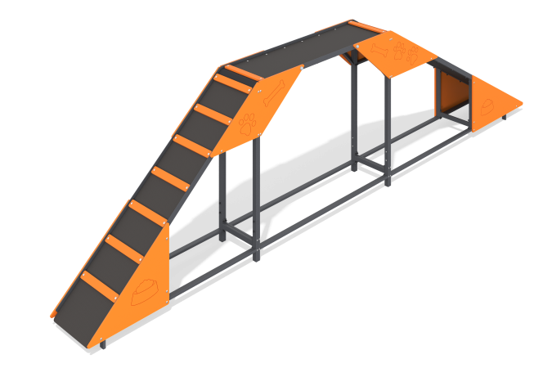

Size, mm: | 424x5010x1275 | Weight, kg: | 126.567
Material characteristics
Materials: Metal, moisture-resistant birch plywood, moisture-resistant laminated birch plywood with anti-slip coating.
The slide-ladder element is a three-section equipment for dogs. The structure consists of a metal frame made of a profile pipe measuring 40 mm x 40 mm x 4 mm, flooring made of laminated plywood 15 mm thick, and plywood decorative thematic elements 12 mm thick. The product is painted with polymer paints.
Contents: Frame - 1 pc., Steps - 14 pcs., Floor - 1 pc., Plywood panels - 8 pcs., fastening kit - 1 pc.

