37.009 |  | Scientific module Cinema
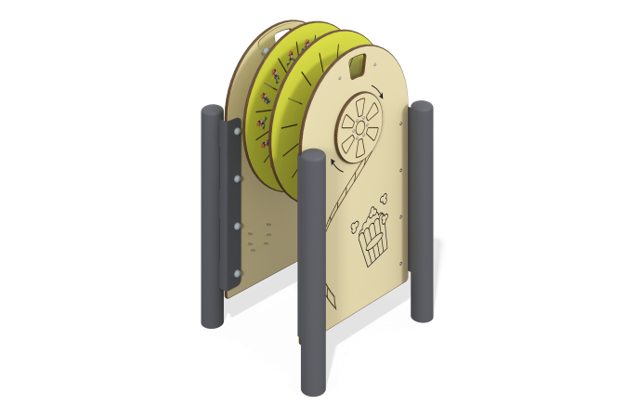

Size, mm: | 643x694x1140 | Weight, kg: | 63.911
Material characteristics
Educational game module
The product is an interactive panel decorated in the theme of the history of the development of cinema. It consists of supporting round metal pipes, to which HPL plastic panels are attached through connectors. Fixed between the main panels are two round HPL discs, connected to each other and to handles on the outer sides of the main panels using a round metal pipe. The disks have drawings of short animations of “horse racing” and “man running” on different sides. A hole is cut in the main panel, the size corresponding to one frame, through which light passes. Rotating the knob changes frames in the hole, and thanks to this you can observe the animation plot. The module presents the operating principle of the first cinema cameras.
Materials: HPL plastic, metal.

