37.008 |  | Scientific module Electrical circuit
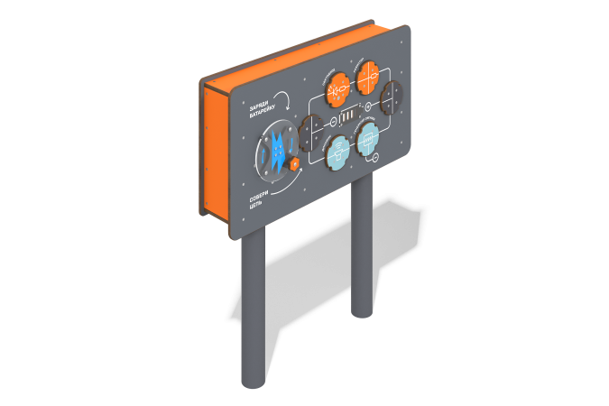

Size, mm: | 319x1215x1500 | Weight, kg: | 121.16
Material characteristics
Educational game module
The module is a panel with chips located on it and a generator handle, designed to create two electrical circuits: with sound and light indication of the circuit closure. Consists of round support pipes, decorative elements made of HPL, generator block with handle and operation indicator.
Materials: metal, HPL plastic

