37.005 |  | Scientific module Listen to the city
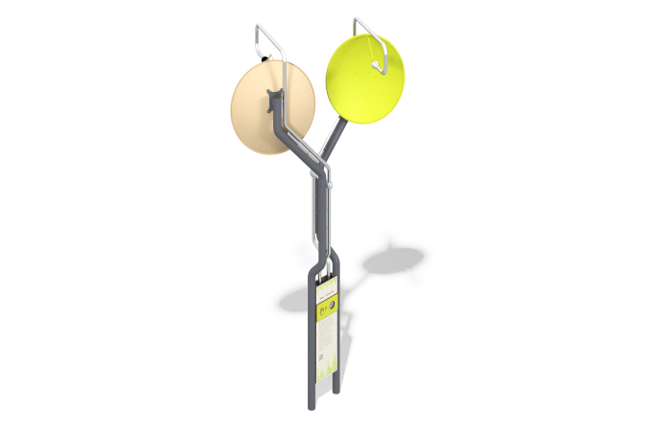

Size, mm: | 1662x2144x4240 | Weight, kg: | 123.553
Material characteristics
Educational game module
The module is a structure of pipes directed upward and ending with bells for capturing (above) and transmitting the sounds of city noise (below). In the upper part, opposite the bells, metal panels are installed to capture sound.
Materials: metal, stainless steel, HPL plastic.

