37.006 |  | Scientific module Shadow play
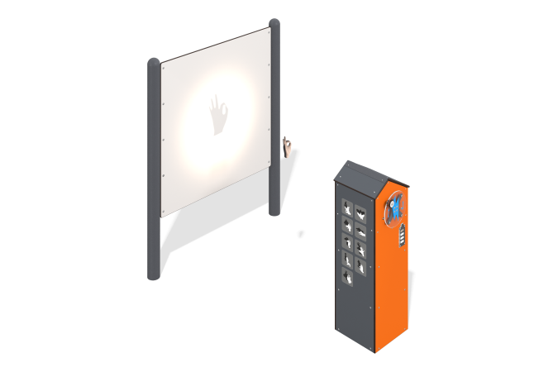

Size, mm: | 1326x2027x1854 | Weight, kg: | 159.549
Material characteristics
Educational game module
The product is a structure consisting of a spotlight with a generator unit with an operation indicator and a screen made of HPL plastic mounted on two metal stands.
The generating set is located inside a housing with a gable roof made of HPL plastic. The case is equipped with a charge indicator in the form of a battery, a spotlight, and a rotating panel made of monolithic polycarbonate with a handle, the rotation of which charges the generator. On the side panel of the case there are images of figures that can be formed by folding a person’s hands. Materials: HPL plastic, metal.

