34.271 |  | Bench with footrest
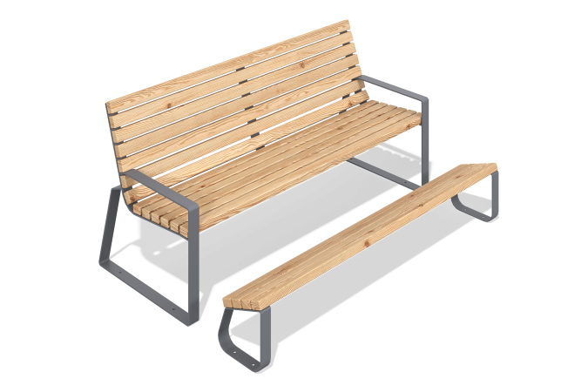

Size, mm: | 1205x1800x1000 | Weight, kg: | 73
Material characteristics
Materials: metal, larch, lacquer.
Package contents: sofa - 1 pc. footrest - 1 pc., a set of fasteners – 1 pc.
The sofa is a welded metal frame made of profile pipes with wooden boards fixed on it. The frame is painted with weather-resistant powder paint, and the wooden elements are coated with a protective varnish resistant to moisture and UV. All fasteners are galvanized."

