34.101 |  | Park Bench HPL
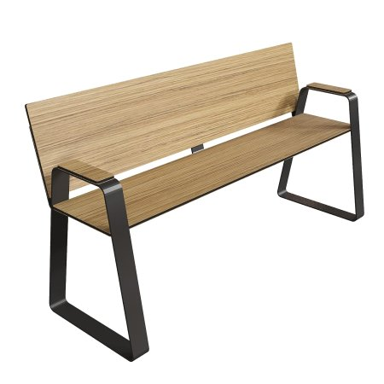

Size, mm: | 400x1500x450 | Weight, kg: | 0
Material characteristics
Materials:
metal, plastic
Package includes:
Park sofa – 1 pc.
The sofa is equipped with a frame made of galvanized sheet metal 4 mm thick with a powder coating that is resistant to corrosion and damage. The seat and back are made of HPL plastic 12 mm thick with a UF coating that provides resistance to ultraviolet radiation and moisture.

