30.172 |  | Stump (Larch) D=200mm
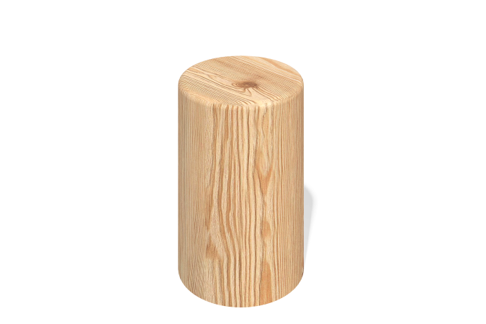

Size, mm: | 200x200x300 | Weight, kg: | 8.97
Material characteristics
Solid larch stump.
Diameter - 200 mm.
Height (total) - 550 mm.
250 mm - depth.
300 mm - from the surface.
Cover the concreted part with sultan.

