19.047 |  | Sandpit Indians
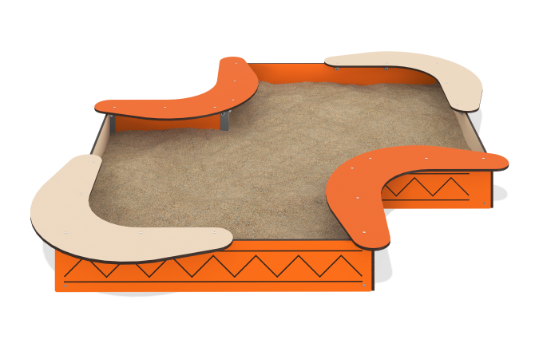

Size, mm: | 2615x2615x255 | Weight, kg: | 75.282
Material characteristics
Materials:
-HPL, orange marigold color, 14 mm thick,
-HPL, beige color, 14 mm thick,
-Metal (sheets 2 mm, 3 mm thick)
-Powder paint.
The product is a gaming element consisting of side walls made of 14mm thick HPL plastic, seats made of 14mm thick HPL plastic and mounting inserts made of steel profile angles with a wall thickness of 3mm. The side walls are connected to the corners using galvanized steel fasteners and stainless steel fasteners, the seats are attached to the walls using steel corners, all bolted connections are closed with plastic decorative plugs.
Equipment:
-Mounting corner 6 pcs.,
-Wall length (1) 2 pcs.,
-Wall length (2) 2 pcs.,
-Seat (1) 2 pcs.,
-Seat (2) 2 pcs.,
- Corners 18 pcs.,
-Set of fasteners and plugs 1 pc.

