35.011 |  | High hound hurdles
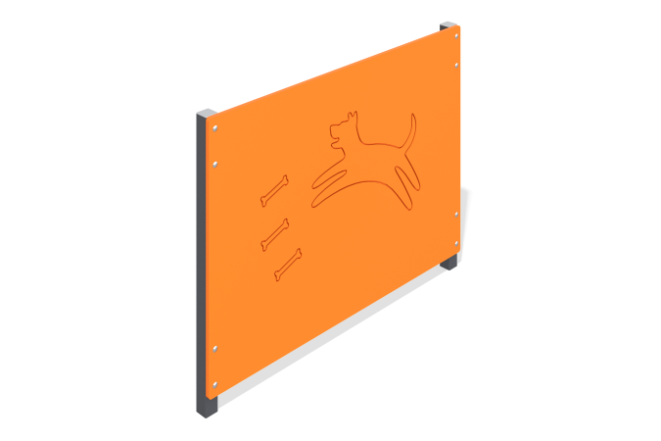

Size, mm: | 55x1000x753 | Weight, kg: | 12.83
Material characteristics
Materials: Metal, moisture-resistant birch plywood.
The dog park high barrier consists of two 40mm x 40mm 2mm thick steel square tubes with 15mm thick moisture resistant birch plywood attached to them. The product is painted with polymer paint. All open parts of the pipes are closed with plastic plugs 40 mm x 40 mm.
Contents: Stands - 2 pcs., shield - 1 pc., fastening set - 1 pc.

