34.245 |  | Park bench radius
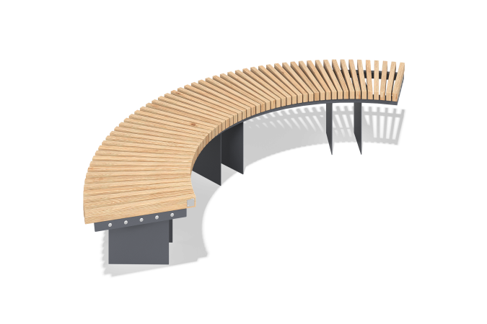

Size, mm: | 976x2461x455 | Weight, kg: | 76.46
Material characteristics
Materials: coniferous wood - pine, metal.
Package contents: frame - 1 pc., supports - 1 set., seat - 1 set., mounting kit - 1 pc.
The bench frame is made of a 40x40 mm profile tube with a wall thickness of 2 mm. The mounting platforms are made of a sheet of metal with a thickness of 4 mm, 5 mm. The bench seat is made of planed pine boards 30x50 mm.
The equipment uses stainless steel fasteners. The protruding parts of the threaded connections and the exposed parts of the pipes are covered with plastic plugs.
Coating of the elements:
- metal - powder zinc grunt, powder paint;
- timber - lessening primer, water-dispersion varnish.

