21.076 |  | Rope Climbing Playground Bernini
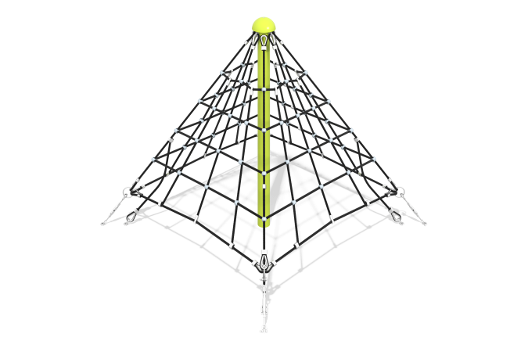

Size, mm: | 2800x2800x1800 | Weight, kg: | 132
Material characteristics
Materials: metal, rope.
Complete set: support pole - 1 pc., rope net - 1 pc., fastener kit - 1 pc.
Support pole made of a 108 mm diameter pipe with powder coating. Pole head made of a steel hemisphere with powder coating. Net made of reinforced six-strand rope with a diameter of 16 mm. Cross-shaped rope connections made of PA6 polyamide, aluminum alloy crimping sleeves. The equipment uses stainless steel fasteners.
Protruding parts of threaded connections and open parts of pipes are covered with plastic plugs
Coating of elements: metal - powder zinc primer, powder paint.

