35.013 |  | Medium hound hurdles
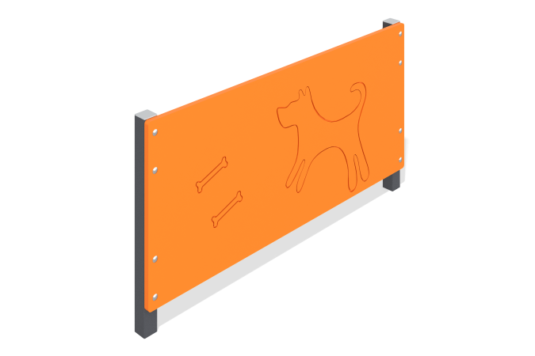

Size, mm: | 55x1000x523 | Weight, kg: | 9.246
Material characteristics
Materials: Metal, moisture-resistant birch plywood.
The medium dog park barrier consists of two 40mm x 40mm square steel tubes, 2mm thick, with 15mm moisture resistant birch plywood attached to them.
The racks are installed on opposite sides of the plywood. The product is painted with polymer paint. All open parts of the pipes are closed with plastic plugs 40 mm x 40 mm, and the fasteners are closed with plastic plugs.
Contents: Stands - 2 pcs., shield - 1 pc., fastening set - 1 pc.

