13.180.1 |  | Play System Cadmium without slide
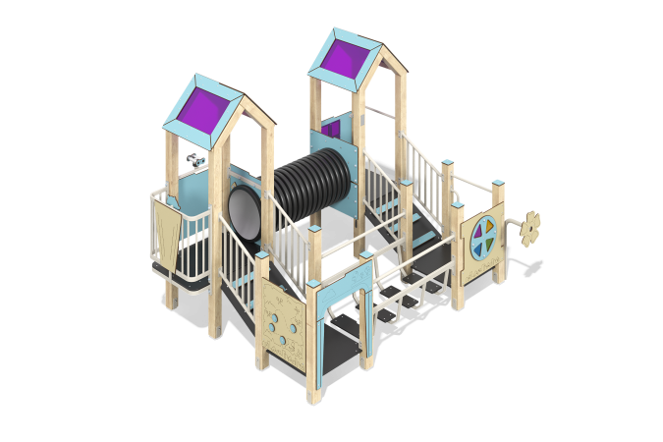

Size, mm: | 2917x3415x2349 | Weight, kg: | 648.6
Material characteristics
Main materials: softwood timber, planed softwood board, HPL with anti-slip coating, HPL plastic, HDPE plastic, metal, stainless steel, monolithic polycarbonate, stainless fasteners.
Package contents: embedded parts – 1 set, support posts – 16 pcs., roofs – 2 sets, floors – 1 set, Manhole with a set of fasteners – 1 pc., fencing and decorative panels – 1 set, inclined ladders with handrails and decorative panels – 2 pcs., tunnel- 1 pc., balcony with steering wheel – 1 pc., Intercom - 1 set, speaker pads - 1 set, binoculars - 1 pc., Color disk panel - 1 pc., handle - 1 pc., crossbars - 3 pcs., mounting kit - 1 pc.
The design and color palette of the equipment according to the sketch.
The game complex consists of 2 towers. The support posts are made of glued softwood timber with a cross section of 100x100 mm. The profile is square, the radius of the rounded corners is R10.
The passage between the towers is represented as a tunnel passage made of HDPE plastic.
The bridge between the platforms is represented as a metal bridge made of 50x25 mm and 40x20 mm profile pipes with a wall thickness of 2 mm and steps made of HPL plastic with anti-slip coating.
The transition between the towers and platforms is presented in the form of an inclined ramp made of HPL plastic with an anti-slip coating and steps made of double-sided HPL plastic with UV protection 10 mm thick. Metal fences are made of 33.5 mm diameter pipe with a wall thickness of 2.8 mm and 26.8 mm diameter transverse tubes with a wall thickness of 2.8 mm).
The floors and steps are made of HPL plastic with anti-slip coating
The roofs of the towers are gable-roofed, made in a combination of HPL plastic frames with monolithic polycarbonate, on which a color coating is applied using UV printing.
The fencing and decorative panels, game elements are made of double-sided HPL plastic with UV protection 10 mm thick. Drawings are applied to the panels and game elements using engraving and UV printing. Decorative inserts on the panels in the form of windows are made of monolithic polycarbonate 5 mm thick with a color coating.
The handles are made of a metal tube with a diameter of 26.8 mm and a wall thickness of 2.8 mm.
The metal crossbars are made of a round tube with a diameter of 21.3 mm and a wall thickness of 2.8 mm.
The game complex has 1 manhole. The manhole is made of 10 mm thick HPL plastic.
The complex uses stainless steel fasteners. The protruding parts of the threaded connections and the exposed parts of the pipes are covered with plastic plugs.
Coating of the elements:
- metal - powder zinc grunt, powder paint;
- timber - lessening primer, water-dispersion varnish.

