30.087 |  | Football goal with basketball post
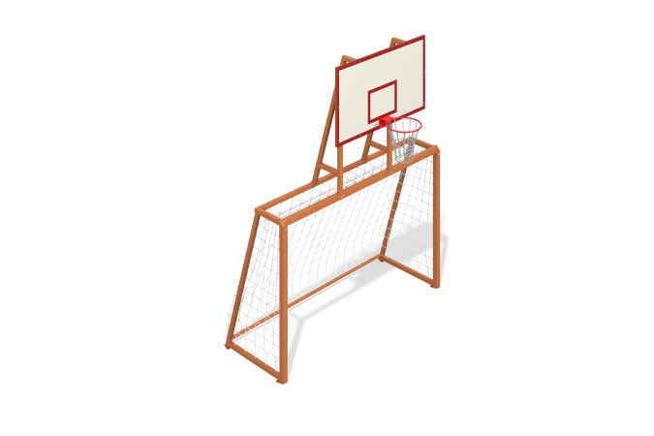

Size, mm: | 2078x3164x3945 | Weight, kg: | 251.134
Material characteristics
Materials: metal, HPL plastic.
Contents: Backboard frame - 1 pc., Backboard - 1 pc., Gate - 1 pc., Anti-vandal basketball hoop - 1 pc., Fastening kit - 1 pc.
The football goal is made of a profile pipe with a cross-section of 80x80 mm and a wall thickness of 3 mm. The shield frame is made of steel pipe 40x40 mm with a wall thickness of 2 mm. A basketball backboard made of 14 mm thick HPL plastic is installed on the frame using bolts. The shield is printed with UV printing. Basketball hoop with a diameter of 450 mm with a metal chain.
The basketball hoop is secured to the frame with bolts passing through the backboard. To impart rigidity to the structure, the frame is secured with ties made from a 40x20mm steel profile pipe with a wall thickness of 2 mm.
All fasteners are stainless.

