19.019 |  | Sandpit Galaxy
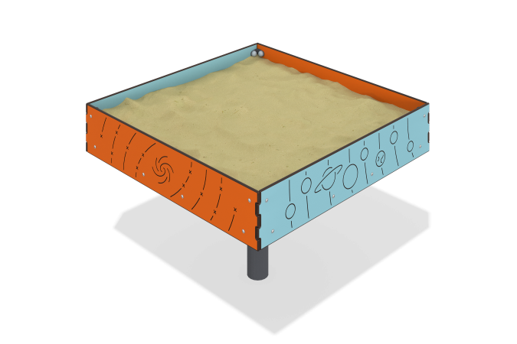

Size, mm: | 1000x1000x700 | Weight, kg: | 41.089
Material characteristics
Materials: HPL plastic, 15mm thick laminated plywood, metal, Powder paint.
The product is a game element consisting of side walls made of HPL plastic, a bottom made of plastic laminated plywood with a thickness of 15 mm, a frame made of a 40x20 profile pipe with a wall thickness of 2 mm, and a 80x80 profile pipe with a wall thickness of 3 mm. and a 20x20 profile pipe with a wall thickness of 1.5mm. The side walls are connected to the frame using galvanized steel fasteners and steel corners, all bolted connections are closed with plastic decorative plugs.
Equipment:
-Mounting embed 1 pc.,
-Frame 1 piece,
-Board version 1 2 pcs.,
-Board version 2 2 pcs.,
-Bottom 1 pc.,
-Set of fasteners and plugs 1 pc.

