35.015 |  | Low hound hurdles
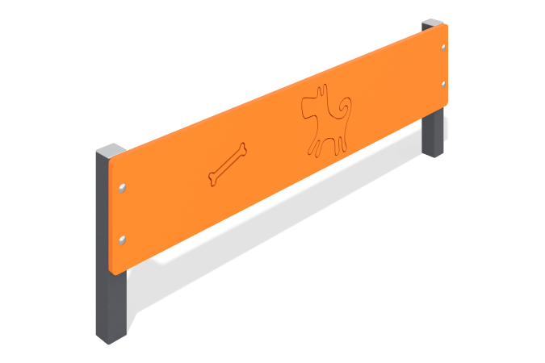

Size, mm: | 52x1000x322 | Weight, kg: | 6.04
Material characteristics
Materials: Metal, moisture-resistant birch plywood.
The dog park low barrier consists of two 40mm x 40mm square steel tubes, 2mm thick, with 15mm thick plywood attached to them. The plywood is decorated with thematic designs applied with a milling cutter. The product is coated with polymer paint. All open parts of the pipes are closed with plastic plugs 40 mm x 40 mm.
Contents: Stands - 2 pcs., shield - 1 pc., fastening set - 1 pc.

