34.109 |  | Park Bench with HPL seats
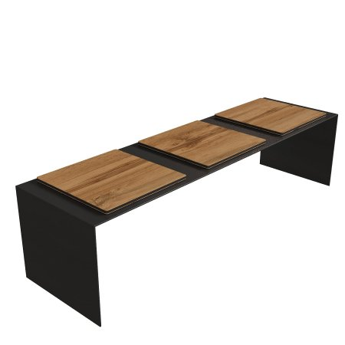

Size, mm: | 450x2000x500 | Weight, kg: | 0
Material characteristics
Materials:
metal, plastic
Package includes:
Park bench – 1 pc.
The bench frame is made of galvanized sheet metal 6-8 mm thick with a powder coating that protects against corrosion and external influences. The seat is made of HPL plastic 12 mm thick with a UF coating that is resistant to ultraviolet radiation and moisture.

