14.024 |  | Carousel Arizona
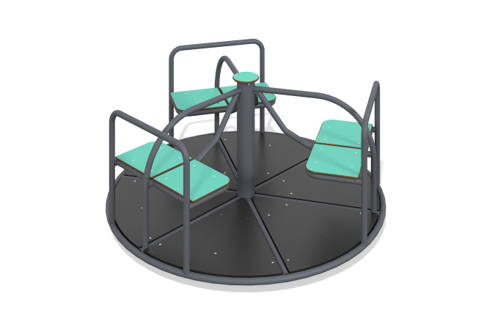

Size, mm: | 1654x1654x797 | Weight, kg: | 128.12
Material characteristics
Materials: Metal, HPL plastic, laminated plywood.
The carousel is a structure consisting of a base, a central pillar, a floor made of laminated plywood with an anti-slip coating, seats made of HPL plastic with metal backs and handrails.
The metal frame is round, made of pipe with a diameter of 33.5 mm. The central post is made of a round metal pipe with a diameter of 108 mm and a wall thickness of 3 mm. The seat crossbars, handrails, and backrests are made of metal pipe with a diameter of 33.5 mm. The frame contains three seats made of 10 mm thick HPL plastic. The floor is made of laminated moisture-resistant plywood 15 mm thick with an anti-slip coating.
All existing metal parts are painted with polyester powder paint.
All protruding parts of the threaded connections are closed with plastic plugs.
Contents: Carousel frame - 1 piece, Seat - 6 pieces, Floor - 1 piece, Fastening kit - 1 piece.

