30.001 |  | Sports Module Football goals 5 meters youth (pipe d = 89mm, with a net)
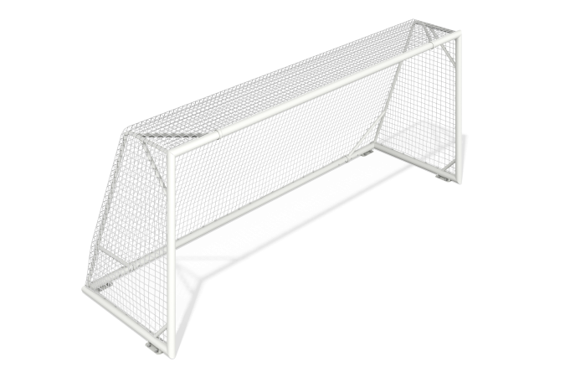

Size, mm: | 1625x5180x2105 | Weight, kg: | 196.616
Material characteristics
Materials: metal, synthetic material.
The gate frame is made of metal round pipes with a diameter of 89 mm and a wall thickness of 3 mm. The frame has loops for attaching the mesh. The stiffening ribs on the back of the gate are made of a metal round pipe with a diameter of 42.3 mm.
The design and color of the gate are in accordance with the attached sketch.
All metal parts are painted with polymer powder paint.
Contents: sidewall – 2 pcs., crossbars – 2 pcs., mesh – 1 pc., fastening kit – 1 pc.

