13.201 |  | Play System Trio
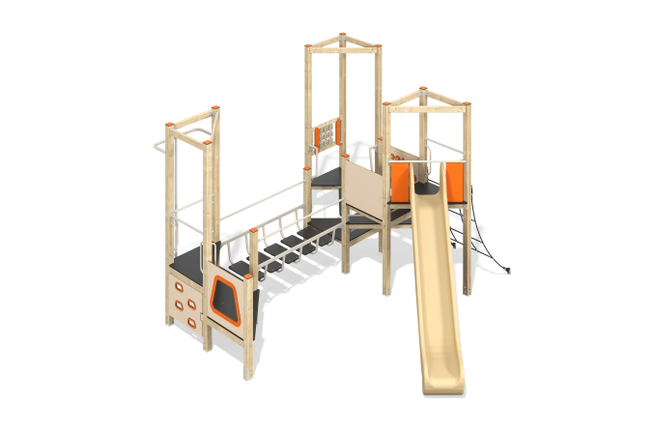

Size, mm: | 4897x4955x2563 | Weight, kg: | 558.8
Material characteristics
Materials: coniferous wood, moisture-resistant plywood with an anti-slip laminated layer, metal, HPL plastic, reinforced polypropylene rope D16 mm.
The racks of the complex are made of laminated veneer lumber with a cross-section of 100mm x 100mm. Profile - square (R10 - corner radius). The top of the timber is covered with caps made of HPL plastic.
The complex consists of three towers with triangular platforms made of moisture-resistant plywood with a laminated anti-slip layer 18 mm thick. Climbing to the platforms of the complex is carried out using a climber's board with slots for grip, an inclined rope mesh made of reinforced polypropylene rope D16 mm. The transitions between the towers are presented in the form of a bridge with a metal frame with steps made of moisture-resistant plywood with a laminated anti-slip layer 15 mm thick, suspended logs on chains (surface - plywood 18 mm thick), a rise from multi-level triangular platforms (plywood 18 mm thick).
The complex includes one plastic slide. The slide has a starting section with side protection, a sliding and braking section.
Game elements: “Rotating Shapes” panel – 1 pc., “Tic-Tac-Toe” panel – 1 pc. Decorative images and branding are made on HPL plastic panels using milling.
Contents: embedded parts - 14 pcs., support bars - 14 pcs., slide - 1 pc., slide embedded - 1 pc., platforms - 7 pcs., climber's board with slots - 1 pc., handles - 7 pcs., crossbars - 4 pcs., "Rotating figures" panel - 1 pc., "Tic-Tac-Toe" panel - 1 pc., hanging log – 1 pc., railings – 2 pcs., bridge – 1 set, pole – 1 pc., rope mesh – 1 set, fastening kit – 1 pc.

