13.200 |  | Play System Neon
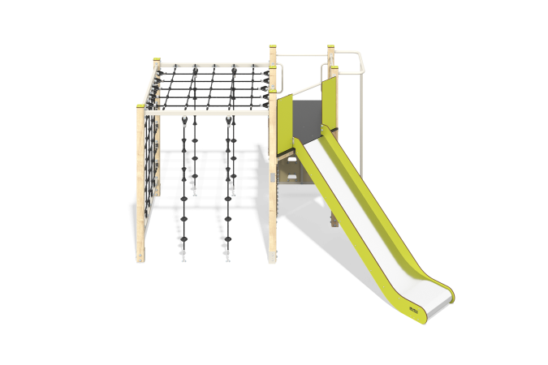

Size, mm: | 3254x4154x2361 | Weight, kg: | 305.97
Material characteristics
Main materials: softwood timber, planed softwood board, laminated plywood with anti-slip coating, HPL plastic, stainless steel, reinforced polypropylene rope, stainless fasteners.
Contents: embedded parts - 1 set, support posts - 7 pcs., floors - 1 set, straight slide h=1.5m - 1 pc., fencing and decorative panels - 1 set, - climber panels with grooves for legs - 1 pc., rope mesh - 1 pc., rope descents - 4 pcs., vertical pole - 1 pc., handles - 4 pcs., ties - 3 pcs., Tic-Tac-Toe panel - 1 pc., fastening kit - 1 pc.
Design and color palette of equipment according to the sketch.
The play complex consists of 1 platform and a rope net. The support posts are made of laminated softwood timber with a cross-section of 100x100 mm. The profile is square, the corner radius is R10.
The rope mesh is made of six-strand reinforced polypropylene rope d=16 mm with a metal frame made of a metal profile pipe with a cross-section of 60x40 mm and a wall thickness of 2 mm.
The floor frames are planed softwood boards with a section of 100x30 mm, 100x40 mm. The floors and steps are made of laminated plywood 18 mm thick with an anti-slip coating.
Fencing and decorative panels, game elements are made of double-sided HPL plastic with UV protection, 10 mm thick. Drawings are applied to panels and game elements using engraving and UV printing.
- climber panels with grooves for legs, made of HPL plastic 10 mm thick;
The handles are made of metal pipe with a diameter of 26.8 mm and a wall thickness of 2.8 mm.
Metal crossbars are made of a round pipe with a diameter of 21.3 mm and a wall thickness of 2.8 mm.
The vertical pole is made of a pipe with a diameter of 42 mm and a wall thickness of 2.8 mm.
Tic-tac-toe is made of laminated coniferous timber with a cross-section of 100x100 mm. The profile is square, the corner radius is R10. The metal plates are made of stainless steel with a thickness of 1.5 mm.
The play complex includes 1 straight slide h=1.5 m. The slide consists of a slope and sides, in turn made of stainless steel sheet 1.5 mm thick and HPL plastic 10 mm thick. The launch pad for the straight slide is equipped with a metal crossbar made of a round pipe with a diameter of 21.3 mm and a wall thickness of 2.8 mm.
The complex uses stainless steel fasteners. Protruding parts of threaded connections and open parts of pipes are closed with plastic plugs.
Element coverage:
- metal - powder zinc primer, powder paint;
- timber - glazing primer, water-dispersion varnish.

