13.127 |  | Play System Silicon
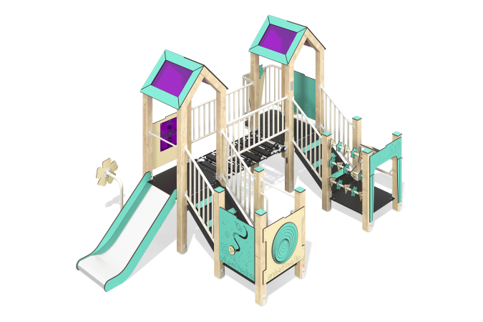

Size, mm: | 2820x4346x2350 | Weight, kg: | 672.92
Material characteristics
Main materials: softwood timber, planed softwood board, laminated plywood with anti-slip coating, HPL plastic, metal, stainless steel, monolithic polycarbonate, reinforced polypropylene rope, stainless fasteners.
Contents: embedded parts - 1 set, support posts - 16 pcs., roofs - 2 sets, floors - 1 set, inclined ladder - 2 pcs., straight slide h=0.7m - 1 pc., rope bridge with steps - 1 pc., metal fences - 6 pcs., fencing and decorative panels - 1 set, balcony with steering wheel - 1 pc., "Abacus" element - 1 pc., intercom - 2 pcs., intercom pads - 2 pcs., "Rotating Labyrinth" element - 1 pc., handles - 2 pcs., ties - 2 pcs., fastening kit - 1 pc.
Design and color palette of equipment according to the sketch.
The gaming complex consists of 2 towers. The support posts are made of laminated softwood timber with a cross-section of 100x100 mm. The profile is square, the corner radius is R10.
The transition between the towers is presented in the form of a rope bridge made of six-strand reinforced polypropylene rope d=16 mm. The rope bridge railing is made of a metal pipe with a diameter of 33.5 mm and a wall thickness of 2.8 mm.
The transition between the towers and the lower platforms is presented in the form of an inclined ladder made of laminated plywood 18 mm thick with an anti-slip coating and steps made of double-sided HPL plastic with UV protection 10 mm thick.
Metal fences are made of a pipe with a diameter of 33.5 mm with a wall thickness of 2.8 mm and transverse tubes with a diameter of 26.8 mm with a wall thickness of 2.8 mm)
The floor frames are planed softwood boards with a section of 100x30 mm, 100x40 mm. The floors and steps are made of laminated plywood 18 mm thick with an anti-slip coating.
The roofs of the towers are gable, made of a combination of frames made of HPL plastic with monolithic polycarbonate, onto which color coating is applied using UV printing.
Fencing and decorative panels, game elements are made of double-sided HPL plastic with UV protection, 10 mm thick. Drawings are applied to panels and game elements using engraving and UV printing. Decorative inserts on the panels in the form of windows are made of monolithic polycarbonate 5 mm thick with color coating.
The handles are made of metal pipe with a diameter of 26.8 mm and a wall thickness of 2.8 mm.
Metal crossbars are made of a round pipe with a diameter of 21.3 mm and a wall thickness of 2.8 mm.
The play complex includes 1 straight slide h=0.7 m. The slide consists of a slope and sides, in turn made of 1.5 mm thick stainless steel sheet and 10 mm thick HPL plastic. The launch pad of the slide is equipped with a metal crossbar made of a round pipe with a diameter of 21.3 mm and a wall thickness of 2.8 mm.
The complex uses stainless steel fasteners. Protruding parts of threaded connections and open parts of pipes are closed with plastic plugs.
Element coverage:
- metal - powder zinc primer, powder paint;
- timber - glazing primer, water-dispersion varnish.

