13.038 |  | Play System Aurum
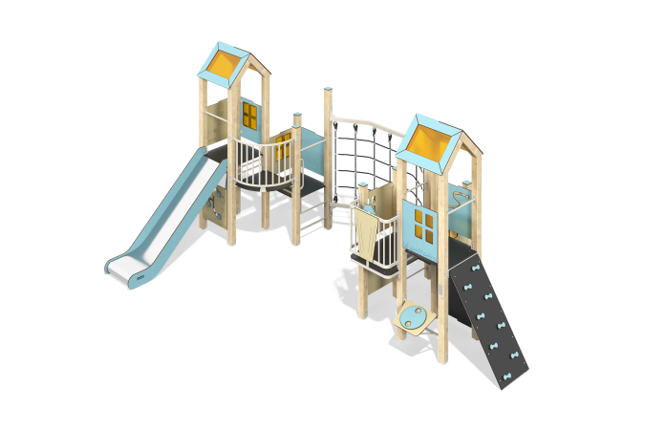

Size, mm: | 3840x5922x2917 | Weight, kg: | 524.04
Material characteristics
Main materials: softwood timber, planed softwood board, laminated plywood with anti-slip coating, HPL plastic, metal, stainless steel, monolithic polycarbonate, reinforced polypropylene rope, stainless fasteners.
Contents: embedded parts – 1 set, support posts – 15 pcs., roofs – 2 sets, floors – 2 sets, climber’s panel with hooks – 1 pc., straight slide h=1.2m – 1 pc., fencing and decorative panels – 1 set, drawing board – 1 pc., balcony with steering wheel – 1 pc., arc balcony – 1 pc., vertical rope mesh - 1 pc., handrails - 9 pcs., "Who Will Eat Whom?" panel - 1 pc., "Fruit" panel - 1 pc., "Don't Get Caught" panel - 1 pc., "Shapes" panel - 1 pc., "Color Wheel" panel - 1 pc., "Geography" panel - 1 pc., "Bench" panel - 1 pc., set fasteners - 1 pc.
Design and color palette of equipment according to the sketch.
The gaming complex consists of 2 multi-level towers. The support posts are made of laminated softwood timber with a cross-section of 100x100 mm. The profile is square, the corner radius is R10.
The transition between the towers is presented in the form of a vertical rope mesh made of six-strand reinforced polypropylene rope d=16 mm with a metal frame made of a metal profile pipe with a section of 60x40 mm and a wall thickness of 2 mm.
The roofs of the towers are gable, made of a combination of frames made of HPL plastic with monolithic polycarbonate, onto which color coating is applied using UV printing.
Fencing and decorative panels, game elements are made of double-sided HPL plastic with UV protection, 10 mm thick. Drawings are applied to panels and game elements using engraving and UV printing. Decorative inserts on the panels in the form of windows are made of monolithic polycarbonate 5 mm thick with color coating.
- climber panels with hooks, made of laminated plywood 18 mm thick with an anti-slip coating.
The handles are made of metal pipe with a diameter of 26.8 mm and a wall thickness of 2.8 mm.
Metal crossbars are made of a round pipe with a diameter of 21.3 mm and a wall thickness of 2.8 mm.
The staircase with decorative panels is made of 24 mm thick plywood, the steps are made of 18 mm thick laminated plywood with an anti-slip coating. The railings are made of pipes with a diameter of 33.5 mm and a wall thickness of 2.8 mm. Decorative panels are made of double-sided HPL plastic with UV protection, 10 mm thick.
The play complex includes 1 straight slide h=1.2 m. The slide consists of a slope and sides, in turn made of stainless steel sheet 1.5 mm thick and HPL plastic 10 mm thick. The launch pad of the straight slide is equipped with a metal crossbar made of a round pipe with a diameter of 21.3 mm and a wall thickness of 2.8 mm.
The complex uses stainless steel fasteners. Protruding parts of threaded connections and open parts of pipes are closed with plastic plugs.
Element coverage:
- metal - powder zinc primer, powder paint;
- timber - glazing primer, water-dispersion varnish.

