13.064 |  | Play System Osmium
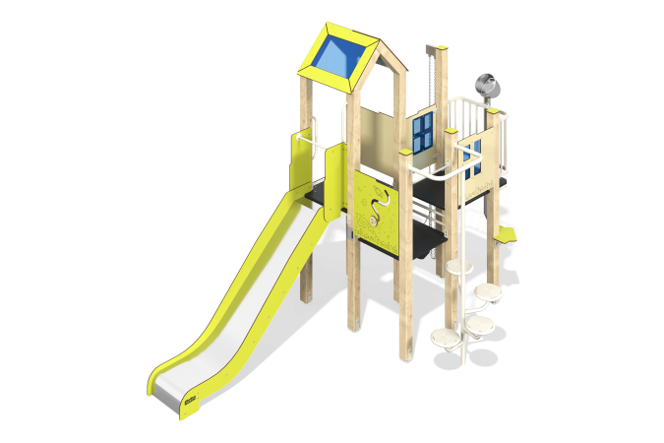

Size, mm: | 3113x4021x2917 | Weight, kg: | 285.8
Material characteristics
Main materials: softwood timber, planed softwood board, laminated plywood with anti-slip coating, HPL plastic, metal, stainless steel, monolithic polycarbonate, stainless fasteners.
Contents: embedded parts – 1 set, support posts – 8 pcs., roofs – 1 set, floors – 1 set, straight slide h=1.2m – 1 pc., fencing and decorative panels – 1 set, spiral staircase – 1 pc., climber’s panel with hooks – 1 pc., table – 1 pc., bench – 1 pc., balcony with sand pipeline – 1 pc., lifting mechanism with bucket – 1 pc., “Galaxy” panel - 1 pc., handrails - 4 pcs., handles - 2 pcs., fastening kit - 1 pc.
Design and color palette of equipment according to the sketch.
The gaming complex consists of 1 tower and multi-level platforms. The support posts are made of laminated softwood timber with a cross-section of 100x100 mm. The profile is square, the corner radius is R10.
The floor frames are planed softwood boards with a section of 100x30 mm, 100x40 mm. The floors and steps are made of laminated plywood 18 mm thick with an anti-slip coating.
The roof of the tower is gable, made of a combination of frames made of HPL plastic with monolithic polycarbonate, onto which color coating is applied using UV printing.
Fencing and decorative panels, game elements are made of double-sided HPL plastic with UV protection, 10 mm thick. Drawings are applied to panels and game elements using engraving and UV printing. Decorative inserts on the panels in the form of windows are made of monolithic polycarbonate 5 mm thick with color coating.
- climber panels with hooks, made of laminated plywood 18 mm thick with an anti-slip coating;
The handles are made of metal pipe with a diameter of 26.8 mm and a wall thickness of 2.8 mm.
Metal crossbars are made of a round pipe with a diameter of 21.3 mm and a wall thickness of 2.8 mm.
The spiral staircase is made of a pipe with a diameter of 42 mm with a wall thickness of 2.8 mm, the landings are made of a pipe with a diameter of 33.5 mm with a wall thickness of 2.8 mm and a sheet of corrugated metal with a thickness of 4 mm.
The play complex includes 1 straight slide h=1.2 m. The slide consists of a slope and sides, in turn made of stainless steel sheet 1.5 mm thick and HPL plastic 10 mm thick. The launch pad for the straight slide is equipped with a metal crossbar made of a round pipe with a diameter of 21.3 mm and a wall thickness of 2.8 mm.
The sand pipeline is made of stainless steel: a pipe with a diameter of 76 mm with a wall thickness of 1 mm and a sheet with a thickness of 1.5 mm.
A sand tap with a rubber bucket, which is attached to a short-link stainless chain, is installed on the beam.
The complex uses stainless steel fasteners. Protruding parts of threaded connections and open parts of pipes are closed with plastic plugs.
Element coverage:
- metal - powder zinc primer, powder paint;
- timber - glazing primer, water-dispersion varnish.

