13.087 |  | Play System Tantalum
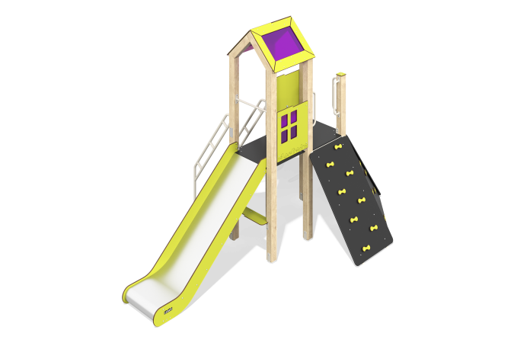

Size, mm: | 2409x4166x2899 | Weight, kg: | 358.27
Material characteristics
Materials: laminated veneer lumber, moisture-resistant laminated plywood 18 mm thick with an anti-slip layer, metal, HPL plastic 10 mm thick, monolithic polycarbonate 5 mm thick
The racks of the complex are made of glued laminated coniferous timber with a section of 100 mm x 100 mm, the profile is square (R10 - corner radius). The beam is covered on top with a plastic cap made of HPL.
The platforms of the complex, the steps of the stairs and the base of the climber’s boards are made of moisture-resistant plywood 18 mm thick, with an anti-slip laminated layer.
The complex includes one tower with a gable symmetrical roof on a wooden frame made of beams. The roof slopes are made of HPL plastic combined with 5 mm thick polycarbonate with color coating.
The complex consists of one slide 1.2 m high with a slope made of stainless steel sheet 1.5 mm thick. The sides of the slide are made of HPL plastic, 10 mm thick. The slide has a starting section with side protection, a sliding and braking section with protective sides and a crossbar for safety.
Game elements: "World Map" panel, climber's board - 3 pcs., slide.
Coating of elements: Polymer coating of metal; processing of lumber - glaze primer, water-dispersion varnish. Stainless steel fasteners are used.
Contents: Embedded parts - set, support posts - 6 pcs., slide crossbar - 1 pc., climber's board - 3 pcs., roof - 1 pc., staircase - 1 pc., stair railing - 2 pcs., slide h=1.2m - 1 pc., bench - 1 pc., fencing and game panel (panel with window, "World Map") - 2 pcs., fastening kit - 1 pc.

