13.053 |  | Play System Lanthanum
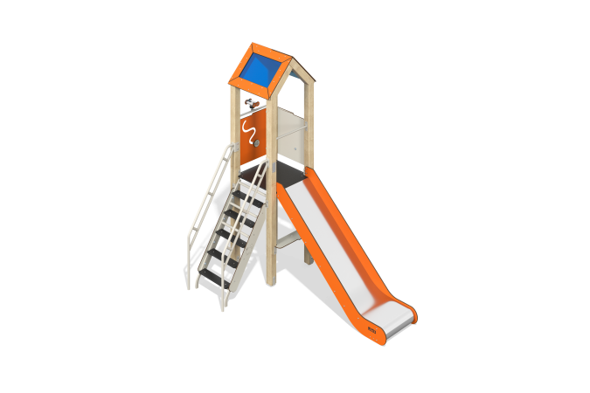

Size, mm: | 1635x2720x2879 | Weight, kg: | 265.8
Material characteristics
Main materials: softwood timber, planed softwood board, laminated plywood with anti-slip coating, HPL plastic, metal, stainless steel, monolithic polycarbonate, stainless fasteners.
Contents: embedded parts – 1 set, support posts – 4 pcs., roofs – 1 set, floors – 1 set, straight slide h=1.2m – 1 pc., fencing and decorative panels – 1 set, staircase with decorative panels – 1 pc., bench – 1 pc., binoculars – 1 pc., crossbars – 2 pcs., fastening kit - 1 pc.
Design and color palette of equipment according to the sketch.
The gaming complex consists of 1 tower. The support posts are made of laminated softwood timber with a cross-section of 100x100 mm. The profile is square, the corner radius is R10.
The floor frame is a planed softwood board with a section of 100x30 mm, 100x40 mm. The floors and steps are made of laminated plywood 18 mm thick with an anti-slip coating.
The roof of the tower is gable, made of a combination of frames made of HPL plastic with monolithic polycarbonate, onto which color coating is applied using UV printing.
Fencing and decorative panels, game elements are made of double-sided HPL plastic with UV protection, 10 mm thick. Drawings are applied to panels and game elements using engraving and UV printing.
Metal crossbars are made of a round pipe with a diameter of 21.3 mm and a wall thickness of 2.8 mm.
The staircase with decorative panels is made of a metal profile pipe with a cross section of 60x40 mm with a wall thickness of 2 mm and a pipe with a diameter of 33.5 mm with a wall thickness of 2.8 mm, the steps are made of laminated plywood 18 mm thick with an anti-slip coating. Decorative panels are made of double-sided HPL plastic with UV protection, 10 mm thick.
The play complex includes 1 straight slide h=1.2 m. The slide consists of a slope and sides, in turn made of stainless steel sheet 1.5 mm thick and HPL plastic 10 mm thick. The launch pad for the straight slide is equipped with a metal crossbar made of a round pipe with a diameter of 21.3 mm and a wall thickness of 2.8 mm.
The complex uses stainless steel fasteners. Protruding parts of threaded connections and open parts of pipes are closed with plastic plugs.
Element coverage:
- metal - powder zinc primer, powder paint;
- timber - glazing primer, water-dispersion varnish.

