23.044 |  | Educational Module Calculations
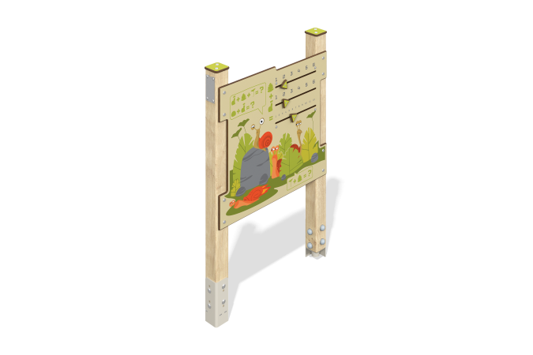

Size, mm: | 110x770x1165 | Weight, kg: | 16.862
Material characteristics
Material: softwood timber, HPL plastic, stainless steel fasteners.
Contents: embedded parts – 1 set, support posts – 2 pcs., “Race” panel – 1 pc., fastening set – 1 pc.
Design and color palette of equipment according to the sketch.
The educational element consists of two supports made of laminated veneer lumber, on which the “Race” game panel is fixed. The support posts are made of laminated coniferous timber with a cross-section of 80x80 mm. The profile is square, the corner radius is R10.
The “Race” game element is made of double-sided HPL plastic with UV protection, 10 mm thick. All decorative elements such as sliders are made of 10 mm thick HPL plastic. Drawings are applied to the panels using engraving and UV printing.
Caps made of HPL plastic with UV protection 10 mm thick are installed on the upper part of the support posts.
The gaming panel uses stainless steel fasteners. Protruding parts of threaded connections and open parts of pipes are closed with plastic plugs.
The “Race” game panel was created for thematic play and motor skills development. Purpose of the “Race” game: You need to set any numbers in the first two rows, and in the third row, use the slider to mark the sum of the first two numbers.
Element coverage:
- metal - powder zinc primer, powder paint;
- timber - glazing primer, water-dispersion varnish.

