39.105 |  | Dumstep enclosure with doors (4 containers)
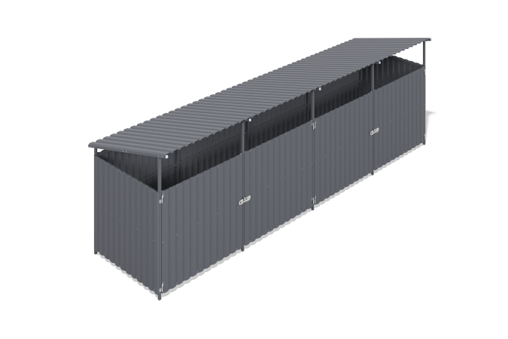

Size, mm: | 1960x6930x2200 | Weight, kg: | 429.662
Material characteristics
Materials: metal.
Complete set: frame - 1 pc., side panels - 2 pcs., roof - 1 pc., doors - 2 pcs., fastener kit - 1 pc.
Four-section container platform with doors is designed to accommodate containers and protects them from rain and other weather conditions. The frame is made of welded walls, lintels and doors made of 40x40 mm and 40x20 mm profile pipes with a wall thickness of 2 mm, flanges and plastic elements. All metal parts are shot blasted, cleaned, degreased and painted with powder paint. The cladding is made of galvanized profiled sheet C20 with a polymer coating, fixed with roofing screws with press washers.

