35.019 |  | Agility tire jump
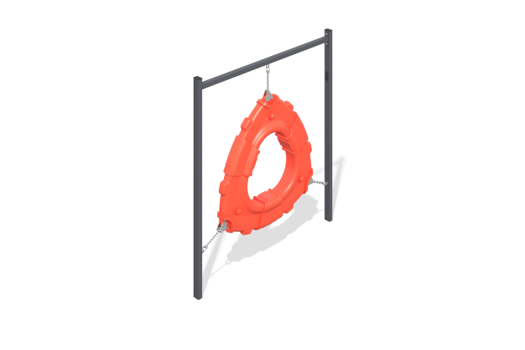

Size, mm: | 156x1500x1620 | Weight, kg: | 23.6
Material characteristics
Materials: Metal, low-density polyethylene.
The dog training ring post consists of two 60mm x 40mm x 2mm wall thickness rectangular steel tubes, a 40mm x 40mm x 3mm wall thickness steel square tube as a crossbar and a HDPE ring truncated at three corners with all corners rounded. The ring is attached with a chain on three sides. Metal painting is done with polymer paint. All open parts of the pipes are closed with plastic plugs 60 mm x 40 mm, and the fasteners are closed with plastic plugs.
Contents: Posts - 2 pcs., Crossbar - 1 pc., Chain - 1 set, ring - 1 pc., fastening set - 1 pc.

