30.008.1 |  | Climbing wall on metal poles
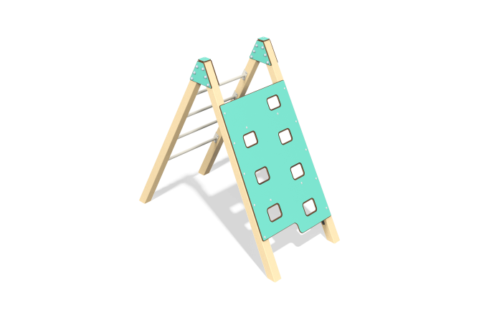

Size, mm: | 951x1927x1590 | Weight, kg: | 84.8826
Material characteristics
Main materials: metal pipes (80x80x3), HPL plastic, metal, stainless fasteners.
Package contents: support posts – 4 pcs., fencing and decorative panels: manhole panel - 1 pc., screed - 4 pcs., side panel - 2 pcs., plug panel - 2 pcs., panel screed - 2 pcs., a set of fasteners.
The wall consists of 4 support posts. The support posts are made of 80x80x3 profile pipes.
The decorative panels and game elements are made of double-sided HPL plastic with UV protection 10 mm thick. The support ties are made of round tubes with a diameter of 26.8 mm with a wall thickness of 2.8 mm and a plate with a thickness of 3 mm.
The house uses stainless steel fasteners. The protruding parts of the threaded connections are covered with plastic plugs.
Coating of the elements:
- metal - powder zinc grunt, powder paint ral 1001 moire and ral 9001 smooth;

