28.077.1 |  | Sports Complex
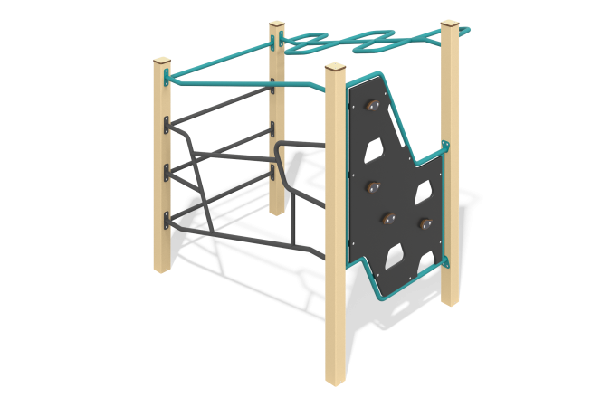

Size, mm: | 1320x1590x1710 | Weight, kg: | 100
Material characteristics
Primary materials: metal, HPL plastic, FW (waterproof plywood).
Scope of supply: 4 pcs. support posts and training elements (climbing wall, overhead ladder, etc.).
Construction:
The complex consists of 4 support posts with a cross-section of 80 mm x 80 mm, made of square metal profile tube. The top ends of the posts are covered with 10 mm thick HPL plastic caps.
Metal components of the crossbars and ladders are made of round tube with an outer diameter of 26.8 mm and a wall thickness of 2.8 mm.
The first section is equipped with an 18 mm thick FW panel with climbing grips. The panel frame is made of round tube with an outer diameter of 26.8 mm and a wall thickness of 2.8 mm. The climbing grips on the panels are made of 10 mm thick HPL plastic.
The other sections are equipped with ladders and an overhead ladder, made of metal round tubes with an outer diameter of 26.8 mm and a wall thickness of 2.8 mm.
Fasteners and protection:
The complex uses AISI 316 stainless steel fasteners, with the exception of zinc-plated threaded rivets. Protruding parts of threaded connections and open tube ends are covered with plastic caps.
Coating of elements:
Metal: Zinc-rich primer, powder coating RAL 1001 (textured) for support posts; RAL 5021 (textured) and RAL 9005 (textured) for training elements.
HPL & FW: HPL 10 1028 graphite and FW 18, black (Climbing wall).
HPL caps: HPL 10 1012 vanilla.

