17.028.1 |  | Swing frame Urban nest on metal poles
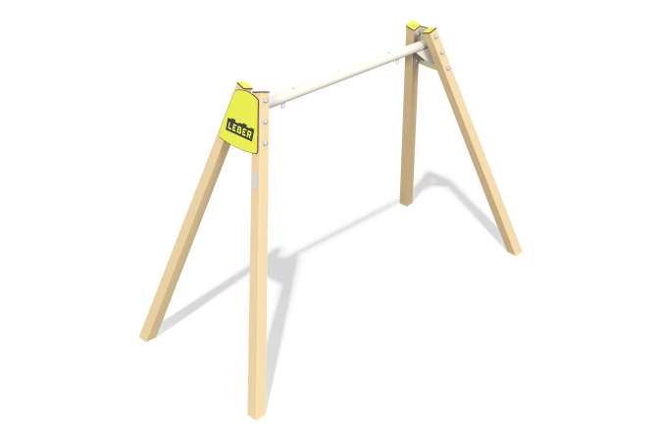

Size, mm: | 1590x3489x2164 | Weight, kg: | 124.2551
Material characteristics
Materials: metal, HPL plastic.
Package contents: Metal racks – 4 pieces, Crossbar – 1 piece, decorative elements from HPL - 6 pieces, a set of fasteners - 1 piece,
The design and color palette of the equipment according to the sketch.
The swing frame consists of 4 metal racks and 1 metal crossbar fixed between them. The support posts are made of a profile tube with a square cross-section of 100x100 mm, the wall thickness is 3 mm. The crossbar is made of a metal tube with a diameter of 89 mm and a thickness of 3 mm. The junction of the racks with the crossbar is covered with 10 mm thick HPL plastic linings. The ends of the pipes are covered with 10 mm thick HPL plastic linings.
The complex uses stainless steel fasteners.
Coating of the elements:
- metal - powder zinc grunt, powder paint.

