34.269 |  | Bench without backrest
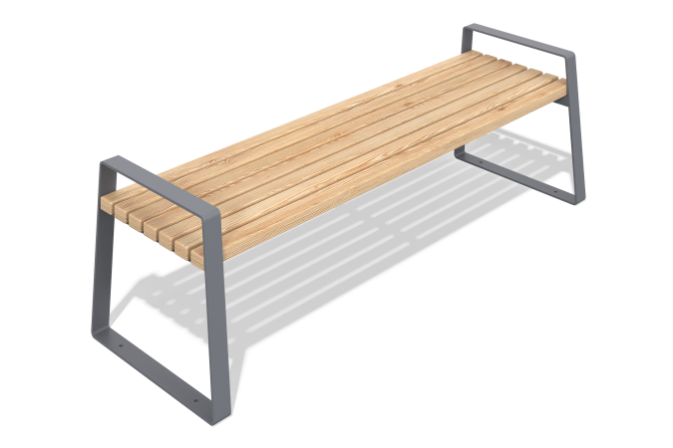

Size, mm: | 590x1800x570 | Weight, kg: | 34
Material characteristics
Materials: larch, metal.
Package contents: park bench assembly – 1 pc.; set of fasteners – 1 pc. The bench is a frame made of metal elements with larch boards mounted on it. Wooden parts are treated with protective compounds for durability and weather resistance. The metal elements are coated with powder paint to protect against corrosion.

