37.012 |  | Lightship
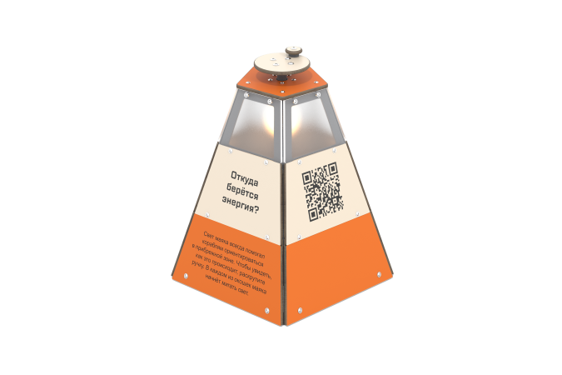

Size, mm: | 582x611x587 | Weight, kg: | 33.952
Material characteristics
Educational game module
The module is a structure made from a generator set with light bulbs located inside a housing made of HPL plastic with windows made of monolithic polycarbonate. At the top of the case there is a round disk with a handle. When the handle is rotated, the generator is charged and the lights inside the installation alternately turn on, simulating the operation of a beacon.
Materials: metal, HPL plastic, monolithic polycarbonate.

