34.193 |  | Arch Playground
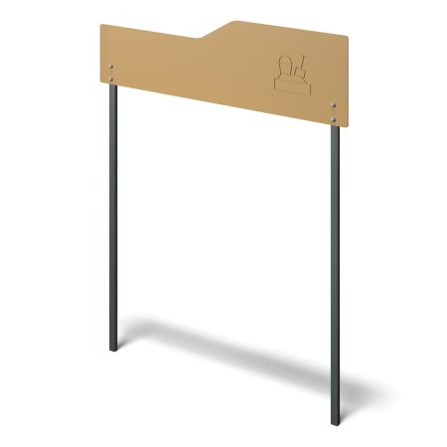

Size, mm: | 75x2400x3000 | Weight, kg: | 41.173
Material characteristics
Materials: Moisture-resistant birch plywood, metal.
The entrance arch for playgrounds consists of 2 posts measuring 60 mm x 40 mm x 3 mm and 15 mm thick plywood fixed to them at a height of 2340 mm from the ground. All open parts of the pipes are closed with 60 mm x 40 mm plugs.
Contents: Stands - 2 pcs., Plywood - 1 pc., Fastening kit - 1 pc.

