19.037 |  | Sandpit Sea with a lid
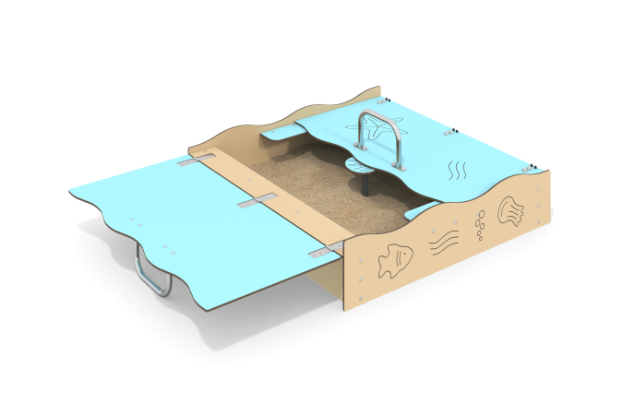

Size, mm: | 1300x1300x514 | Weight, kg: | 44.9
Material characteristics
Materials:.
-HPL 10 mm thick.
-Stainless steel.
-Metal
-Powder paint.
Open dimensions: width 1300 mm x length 2634 mm x height 300 mm.
The product is a gaming element consisting of side walls, seats, covers made of 10 mm thick HPL, stainless steel handles, and mounting inserts made of 3 mm thick sheet. The table consists of a stand made of pipe with a diameter of 33.5 mm and a table cover made of HPL 10 mm. The side walls are mated with the embedded corners using stainless steel fasteners. The seats are attached to the walls using steel angles, all bolted connections are closed with plastic decorative plugs.
Equipment:
- Corner 4 pcs.,
-Table stand 1 pc.,
-Table cover 1 pc.,
-Front wall 2 pcs.,
- Side wall 2 pcs.,
-Shelves 2 pcs.,
-Lids 2 pcs.,
-Handles 2 pcs.,
-Set of fasteners and plugs 1 pc.

