26.050 |  | Workout System Swedish wall
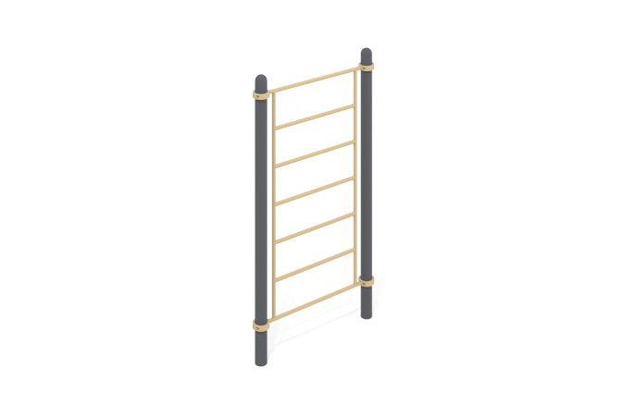

Size, mm: | 150x1358x2554 | Weight, kg: | 81.481
Material characteristics
Materials: metal, powder paint.
The complex consists of 2 support pillars made of a metal pipe with a diameter of 108 mm with a wall thickness of 3 mm and 1 handlebar, made of a round metal pipe with a diameter of 33.5 mm and a wall thickness of 2.8 mm.
The upper part of the pillars is closed with an elliptical metal cap.
The connection of the handle bar to the support pillars is made using dismountable metal clamps with a diameter of 108 mm.
All existing metal parts are painted with polyester powder paint.
All fasteners are galvanized.
Equipment:
Support pillars – 2 pcs.
Handlebar – 1 pc.
Clamps – 4 pcs.
Fastening kit - 1 pc.

