33.001 |  | Information board with pockets (compact)
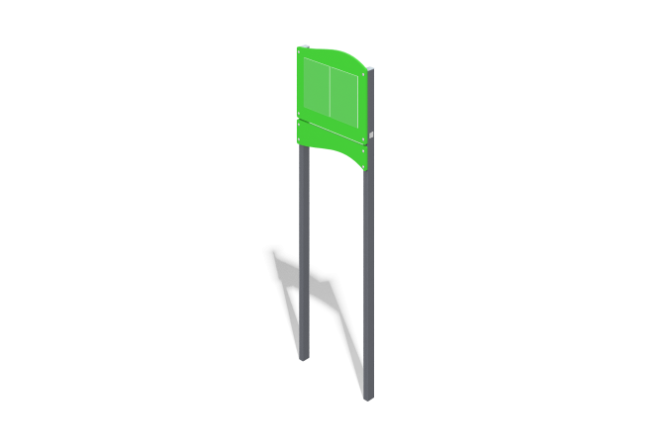

Size, mm: | 150x711x2069 | Weight, kg: | 26.6
Material characteristics
Materials: plywood, metal.
The product consists of upper and lower shields mounted on racks. The boards are made of plywood 15 mm thick. The top shield has transparent pockets for sheets.
The racks are made of square metal pipe 60 mm x 40 mm, with a wall thickness of 3 mm. The top of the racks are closed with plastic plugs. Metal and plywood are painted with polymer paint. All open parts of pipes and bolted connections are closed with plastic plugs of the appropriate size.
Contents: racks – 2 pcs., upper shield with pockets – 1 pc., lower shield – 1 pc., fastening kit – 1 pc.

