30.027 |  | Sports Module Racks with a net
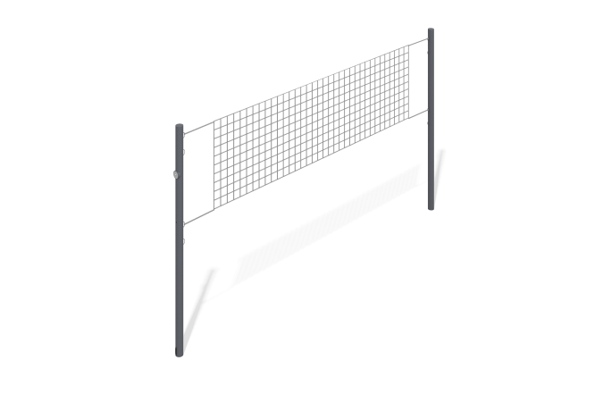

Size, mm: | 89x10000x2550 | Weight, kg: | 39.04
Material characteristics
Materials: metal, mesh.
Volleyball stands consist of two support pillars and a net stretched between them. The posts are made of steel pipe with a diameter of 89 mm x 3 mm. Metal painting is done with polymer paint.
Contents: Post - 2 pcs., Mesh - 1 pc., Fastening kit - 1 pc.

