31.008 |  | Fitness Station Hand walker
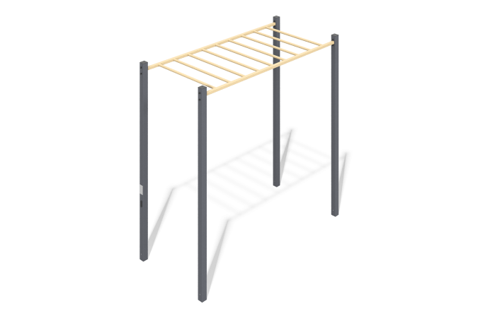

Size, mm: | 1210x2660x2504 | Weight, kg: | 118.802
Material characteristics
Materials: metal, powder paint.
The design consists of: Profile pipe 80x80x3 (racks);
Profile pipe 60x40x3 (beams of the Stairs);
Pipe DN 25x2.8 mm (rungs of the Staircase);
The open parts of the profile pipes are closed with plastic plugs;
All available metal parts are painted with polyester powder paint:
The racks are painted;
Beams and crossbars are painted;
The fastening kit is galvanized.
It is concreted to a depth of 500 mm.
Equipment:
Stand – 4 pcs.
Ladder – 1 pc.
Fastening kit – 1 pc.
Set of plugs – 1 pc.

