30.043 |  | Playing element Labyrinth 2
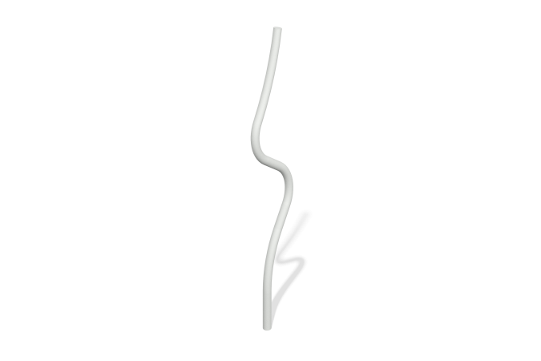

Size, mm: | 200x401x2197 | Weight, kg: | 16.0985
Material characteristics
Materials: metal.
Contents: assembled game element - 1 pc., set of fasteners - 1 pc.
The game element consists of a bent pipe, which is made of a metal pipe with a diameter of 76 mm and a wall thickness of 3 mm.
Element coverage:
- metal - powder zinc primer, powder paint.

