23.055 |  | Chalk board
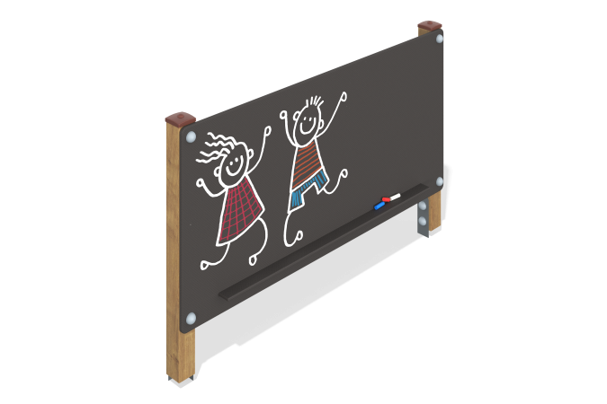

Size, mm: | 120x2000x1200 | Weight, kg: | 42
Material characteristics
Materials: Laminated plywood, laminated veneer lumber, metal, varnish.
The game element consists of 2 support pillars with a cross-section of 100 mm x 100 mm, made from laminated veneer lumber, consisting of three layers of dry softwood boards. On the edges of the pillars, in the center, along the entire length there is a milled unloading groove. All posts are polished, the edges are rounded (rounding radius 20 mm). The treated surfaces are covered with tinted and colorless varnish. The upper ends of the pillars are closed with plastic plugs.
The upper part of the vertically located pillars is covered with plastic decorative plugs.
At the base of the support pillars there are embedded elements made of metal 4 mm thick, 700 mm long, in section shaped like a corner, with a shelf width of 84 mm.
All bearings are powder coated.
The drawing board is made of high-strength, moisture-resistant laminated plywood 15 mm thick.
Equipment:
Pillars – 2 pcs; drawing board – 1 pc., fasteners – 1 set.

