40.034 |  | Lawn fence post 40x40 (h=500)
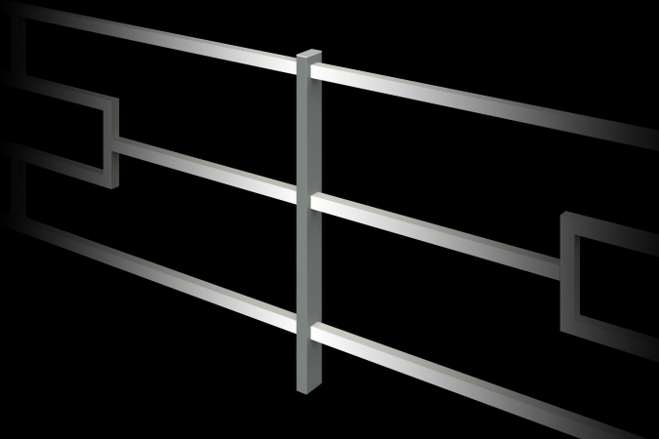

Size, mm: | 40x40x600 | Weight, kg: | 2.381
Material characteristics
Materials: metal, powder paint.
The design consists of a profile pipe with a cross-section of 40 mm x 40 mm with a wall thickness of 2 mm, and a plastic plug for the pipe.
All existing metal parts are painted with polyester powder paint.
Contents: Pole – 1 piece.
Plastic plug – 1 pc.

