37.013 |  | Play System Science mini
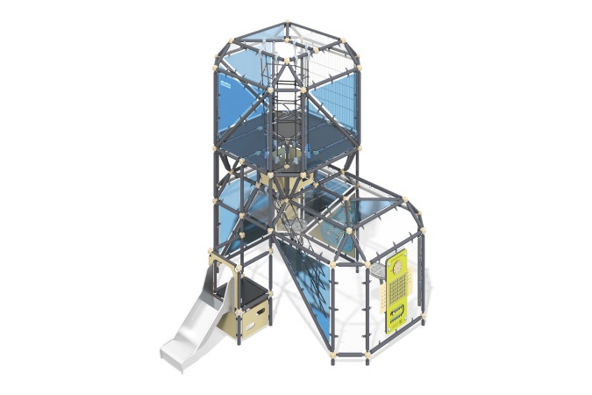

Size, mm: | 3542x3896x4202 | Weight, kg: | 1296
Material characteristics
Main materials: metal, laminated plywood with anti-slip coating, HPL plastic, stainless steel, monolithic polycarbonate, reinforced polypropylene rope, stainless fasteners.
Contents: embedded parts - 1 set, frame rods - 154 pcs., transparent panel - 35 pcs., floors - 1 set, marchi unit - 64 pcs., slide - 1 pc., decorative panels - 3 sets, balancing game "Billiards" - 1 pc., metal mesh - 1 pc., balancing game "Gate" - 1 pc., mesh - 2 pcs., fastening kit - 1 pc.
Design and color palette of equipment according to the sketch.
The gaming complex consists of 2 floors, which are connected by a rope ladder. The frame of the complex consists of conventional parallelepipeds with cut corners, the faces of which are metal rods. The rods of the complex are made of metal pipe, round pipe with a diameter of 57 mm and a wall thickness of 3 mm. The frame is connected using markha knots. The modules are connected by rope manholes made of six-strand reinforced polypropylene rope d=16 mm. The glazing of the complex is made of monolithic polycarbonate 10 mm thick, onto which color coating is applied using UV printing. On the second floor of the complex, the enclosing mesh is made of a 40x20 profile pipe with a wall thickness of 2 mm and a metal mesh of 1.03x2.5 m. The entrances of the complex are designed in the form of a rope ladder, rope mesh, and free areas between frame elements. The floors are made of 15 mm thick laminated plywood with an anti-slip coating. The complex features an open straight slide made of 1.5 mm thick stainless steel sheet. Straight slide h=560 mm. consists of a slope and sides, in turn made of stainless steel sheet 1.5 mm thick. The handrail of the slide is made of a round stainless steel pipe with a diameter of 26.9 mm and a wall thickness of 2 mm. The staircase that leads to the slide and to the 2nd floor is made of 10 mm thick HPL plastic, with grooves for the feet cut out inside it.
The developmental elements of the complex include a stadiometer, a calendar, and a labyrinth, which are made of 10 mm thick HPL plastic. The complex also includes the balancing game “Billiards” and the balancing game “Gate”. The educational element “Billiards” is a game panel with holes and balls that need to be rolled into the holes. The base of the module is made of HPL plastic, the guard is made of stainless steel, the cover is made of transparent polycarbonate. The educational element “Gate” is a game panel with stainless steel “gates” with numbers printed on them, and a ball that needs to be rolled into the gate to earn points. The base of the module is made of HPL plastic, the guard is made of stainless steel, the cover is made of transparent polycarbonate.
The complex uses stainless steel fasteners. Protruding parts of threaded connections and open parts of pipes are closed with plastic plugs.
Element coverage:
- metal - powder zinc primer, powder paint.

