21.072 |  | Rope Climbing Playground Astraea
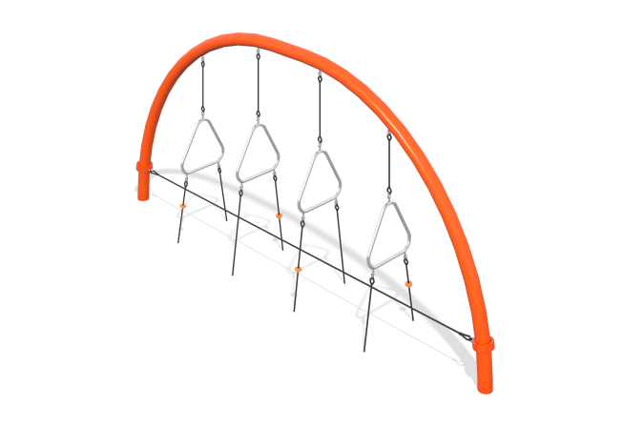

Size, mm: | 600x4870x2300 | Weight, kg: | 219
Material characteristics
Materials: metal, rope
Set includes: supports - 2 pcs., rope - 1 pc., fastener kit - 1 pc.
The posts are made of 133 mm bent galvanized pipes with powder coating, reinforced 6-strand rope with a diameter of 16 mm, aluminum alloy crimping sleeves, steel clamps coated with a polymer coating. Multi-level play elements made of stainless steel, secured to the posts with a rope.
Protruding parts of threaded connections and open parts of pipes are covered with plastic plugs
Coating of elements: metal - powder zinc primer, powder paint.

