MG0002 |  | Seesaw 4-seater
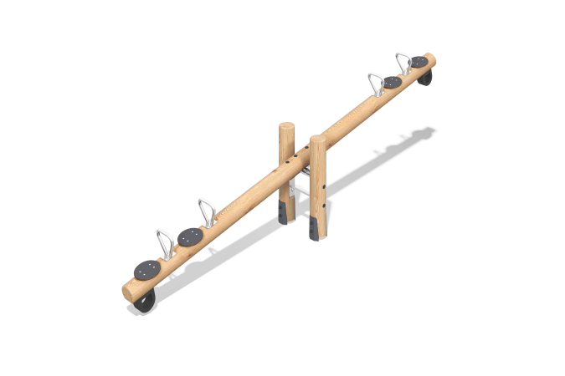

Size, mm: | 510x3750x845 | Weight, kg: | 13.9204
Material characteristics
Materials: softwood (larch), stainless steel, laminated plywood, rubber bumper, stainless steel fasteners.
Package includes: 2 support posts, 1 balance beam, 4 handles, 4 seat, 2 dampers, 1 set of fasteners.
The support posts and beam are made of rounded larch beam with a diameter of 140 mm. The balance beam handles and mounting platform are made of stainless steel. The seat is made of moisture-resistant laminated plywood with a thickness of 21 mm. A rubber bumper measuring 150 x 150 x 80 mm is used to prevent abrupt stops. The through hole size is 90 x 90 mm. It is secured to a flat surface with bolts and M10 nuts.
The equipment uses stainless steel fasteners. Protruding threaded connections and exposed pipe sections are covered with plastic plugs.
Finishing:
- Metal: zinc powder primer, powder paint;
- Timber: translucent primer, water-based varnish.

